2024

U/toasterifclj

[Company name]

1/1/2024

Ultimate iOS compatibility chart Rev:1.2

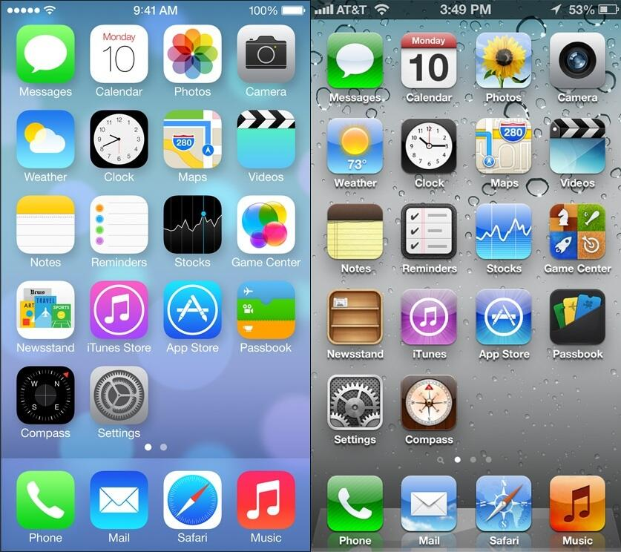

|  |  |  |  |  |  |  |
| --- | --- | --- | --- | --- | --- | --- |
|  | Changing the plist | Patched iOS 6 YouTube | Browser | Tube Fixer | Tube repair | Mobilestreamviewer.tk |
| Ios 10 | 17.03.02 |  |  |  |  |  |
| Ios 9 |  |  |  |  |  |  |
| Ios 8 |  |  |  |  |  |  |
| Ios 7 |  |  |  |  |  |  |
| Ios 6 | Most recent |  |  |  |  |  |
| Ios 5 |  |  |  |  |  |  |
| Ios 4 |  |  |  |  | Not yet |  |
| Ios 3 |  |  |  |  | Not yet |  |
| Ios 2 |  |  |  |  |  |  |
| Ios 1 |  |  |  |  |  |  |

YouTube chart

Key

* Grey: not available
* Green: working
* Red: not working at all.
* Yellow: only on certain devices
* Orange uncertain

Things to note.

* I have tried all of these on their last revision so ios 7.1.2 for example (except I used 6.1.3 a couple of times, but it really made no difference except with minion rush, spoiler neither worked)
* I downloaded the latest version when I could, however if one ipa worked on several devices I just used that one.
* I know there are some differences in functionality between 4.3.x and 4.2.1 however I only had 4.3.x devices on hand my ipod touch 2 died before I started making this list when I end up fixing it I may try some of these again
* I have used checkmate store when downloading all of the apps from the store so if I can’t find a version it’s not because I don’t have checkmate store though if you have any ipa files I may be missing let me know.
* Twitter will be coming in the next major revision of this I want to hold off because of the state of twitter and me having issues with my account.
* I’ve also heard like 300 conflicting ways to get twitter working on ios 4-10 if anyone can make a guide let me know.
* Ios 11 is still too new for me to put it on this list even though it is considered legacy. most apps should work maybe in version 2.0 of this list (coming next year) I will put it there but not right now.
* iPhone os 2 or iOS 2 as its dubbed, is a nightmare to use in 2023 it took me 5 hours even to get there ( I had to use a touch 1) and when I did I found that the main jailbreak tools didn’t work properly on any system that I tried and legacy ios tool kit doesn’t support it even then there’s no appsync support ( you have to use mobile installation a super old fix for fake sign ipas)
* if you have a jailbroken ipsw for ipod 1,1 v2.2.1 please send it to me.
* Also, iphoneos 1 has no app support so no real reason to try it I guess I could try these all in the browser but for 90% of them the browser really didn’t help much.
* I edited the info.plist to the most recent version when I thought it might help or if there was an update nag or occasionally I used an older version number when I thought it could help. If you have a version number that worked that you think I hadn’t tried let me know
* Each app is tested with the capabilities of that version in mind so with reddit on ios 7 for instance you can’t get chat messages, but it didn’t have the capability too but everything that version could do is still working so it would be listed as fully functional.
* I have marked each square with a color however given so many are colorblind I have also put a symbol so you can still read it key is at the bottom of the chart
* I also did not count having to sideload the most recent version as extra work but I did list when you needed to do it
* I do have one confirmed working ipa on ios 2 turns out pandora also works if you can find a v 2.x.x version that is the only one, I tested and not even on a ios 2 device because as I said ios 2 sucks in 2023.
* I’m also not counting privately hosted servers such as yt2009, or retrogram atm.

|  |  |  |  |  |  |  |  |  |
| --- | --- | --- | --- | --- | --- | --- | --- | --- |
|  | 10 | 9 | 8 | 7 | 6 | 5 | 4 | 3 |
| Facebook | / | / | / | / | * | * | * | ? |
| Reddit/alien blue | * | * | / | / | + | + | + | + |
| Spotify | + | * | * | X | X | X | X | X |
| Instagram | / | / | * | * | - | - | X | X |
| Netflix | / | / | # | X | X | X | X | X |
| Discord | / | + | + | + | + | + | X | X |
| Shazam | / | / | X | X | X | X | X | X |
| Messenger | / | / | / | / | ? | X | X | X |
| Minecraft pocket edition | * | * | + | * | * | * | * | X |
| dropbox | * | * | * | * | * | * | ? | ? |
| IHeart radio | / | / | / | / | / | / | - | - |
| Subway surfers | + | * | * | * | * | * | * | X |
| Pandora | / | / | / | / | / | / | / | / |
| Sound hound | / | / | / | / | / | / | / | + |
| Big oven | / | / | / | / | / | / | + | + |
| Minion rush | + | + | + | + | X | X | X | X |
| foursquare | / | + | + | + | * | * | X | X |
| Smule magic piano | / | / | + | + | + | - | - | - |
| Wikapedia clients  Wikipanion  Official Wikipedia app  etc | + | + | X | X | + | + | + | + |
| Urban dictionary | / | / | / | / | / | / | + | + |
| Google earth | / | / | + | + | + | + | X | X |
| waze | / | / | / | / | / | + | X | X |
| Tubi | / | / | ? | ? | ? | ? | X | X |
| Jetpack joyride | * | * | + | + | * | * | * | * |
| Google maps | / | / | / | / | / | / | / | / |
| Default stock/weather app | / | / | / | + | + | + | ? | ? |
| Tumblr | / | / | / | + - | X | X | X | X |

KEY

* Green/: mostly or completely functional (at least for the capabilities of that version)
* Light green*: partially functional some issues
* Yellow-: barley functional major issues (will let you do a couple of things but very unusable)
* Red X: completely nonfunctional or N/A(can’t use any features it can still load but you can’t do anything)
* Orange ?: uncertain (there may be a way to get It working that others have found out or I have speculated but idk)
* Grey#: I can’t find a version that is the latest or will let me download even with checkmate store or sideloading.
* Blue +: needs modifications to get it working like changing the version number or sideloading an older version.

|  |  |
| --- | --- |
| apps | Notes |
| Misc ones not on the list or may be coming in a later revision | -Twitter: Read the things to note page  - snapchat doesn’t seem to work on any version I tried so just putting 10 reds made no sense  - Roblox this one is strange but apparently if you follow [this guide](https://www.reddit.com/r/oldrobloxrevivals/comments/14t0gvd/powdereds_patching_guide/) you can set up Roblox sever and connect it to any device iOS 5 and up  -skype coming in a later revision I need to figure out the logistics of it all also it appears to have jailbreak detection  -Hulu I don’t have an account Almost every delisted version  -Mercari considered this one because it was the only shopping app that let me download ios 4 up but no version seemed to work even with a plist change  - telegram I don’t use it and I’ve heard a lot of stuff about it shutting down rn (on older versions that is)? Might come in a later revision.  - Deezer I’ve heard will work with tweaks on some very old versions (in next revision  - crackle works sort of on ios 5-10 but its acting weird so I need to take a closer look. |
| YouTube | * Mobilestreamviewer.tk is down at the time of me writing this 10/16/2023 I’m hoping it will come back up soon but I’m not sure * Tube fixer has only ever really worked well for me on 5-6 YOU NEED THE IRSG ROOT CERTIFICATE [DOWNLOAD FROM HERE](https://cydia.invoxiplaygames.uk/certificates/) a ton of tutorials don’t explain it because it used to not be [necessary](https://www.youtube.com/watch?v=DQbFK1J2lto&t=4s) * Tube repair, use youtube 1.1.0 ipa * If you need help with tube repair [go here](https://web.archive.org/web/20240119114930/http:/tuberepair.mali357.gay/guide/) credit to bag.xml * If tube repair is not working for you may want to try a different url * [Ios 3 tutorial](https://www.reddit.com/r/LegacyJailbreak/comments/1bu49wn/tutorial_tubefixer_ios_3/) by me * [https://cydia.skyglow.es:5005/](https://cydia.skyglow.es:5005/-) - requis * <http://cydia.skyglow.es:5007/> - requis * <http://tuberepair.sfproj.xyz/> - savefade * I did not mention yt2009 its kinda unstable on ios its still probably the best option on ios 4.3.3. |
| Facebook | * Messages and notifications don’t work ios 6. * Use version 5.0 to get ios 5 and ios 4.3 working available [in my ipa collection](https://archive.org/details/toasterifc-ipa-collection) (it’s the only fb one in there). |
| Reddit/alien blue | * Ios 3-4 need alien blue plus connection to muellers software.org http proxy [explanation](https://www.reddit.com/r/LegacyJailbreak/comments/13tnimh/tutorial_how_to_fix_safari_cannot_display_this/). * Ios 5-6 you need alien blue plus for 6 (you may) need the ssl patched version * Ios 7-8 don’t have messages but never did so no need to mention it. * Ios 9 won’t let you log in, [fix](https://www.reddit.com/r/LegacyJailbreak/comments/1alx7ho/tutorial_how_to_get_working_reddit_app_on_ios_935/) * Ios 10 messages wont function. |
| Spotify | Ios 3-7 error 409 when logging in  Ios 8-9 I have loading errors with these two sometimes.  Ios 10 will not let you log in download the ios 8 client and sideload that. |
| Instagram | Ios 3-4 will not let you log in.  Ios 5 log in screen will progress but then the app will crash.  Ios 6 will log in, but no posts will load. Following does not work either I also think you need a account with no email linked too it .  Ios 7-8 no posting, no messaging.  Ios 9-10 no reels you can load vids not reels in particular.  There are some private server revivals by savefade but since they don’t stream data from Instagram it doesn’t count for this. |
| Netflix | Shout out to r/legacyjailbreak for helping with this.  Ios 3-4 won’t even load in fact for 3 It has been like this since [2014, outdated 8 bit guy vid](https://www.youtube.com/watch?v=g5PYhs_DnFI)  Ios 5-7 tell me that I can’t log in or my password is incorrect.  Ios 8 holy shit I have looked everywhere but I cannot find a version for 8 it allegedly works but It let me download and there is no archived version anywhere I looked.  OK so update @Brac0 has it but for some reason it can’t be cracked.  By the way I would like to personally thank Netflix for not having a version that apparently works /s.  I would also like to thank the guy on the internet archive who uploaded an encrypted version of the Netflix app for iOS 8 which I can apparently bypass with the iOS 6 bug /s.  I’ve heard that if you use a kodi support file u may be able to get it too work on ios |
| Discord | Ios 3-4 have no current solutions.  Ios 5-9 work HOWEVER you need to use a SPECIFC discord classic ipa the one In the invoxiplaygames.uk repo is outdated  For ios 7-9 you can also use disc old form invoxiplaygames repo I know it works on 9 but that’s the only one I have tested  Ios 10 discord works with no modification.  [Discord old tutorial](https://www.youtube.com/watch?v=OXditdmF2Ag) and [how to get your token](https://www.youtube.com/watch?v=LnBnm_tZlyU) |
| Shazam | Only 9-10 work and are also the only ones that will download.  I tried changing the plist but that was ineffective I did sideload every version. |
| Messenger | -I don’t think ios 3-4 have a version of messenger  - I can’t get it working on ios 5  - I’ve tried the ssl patched version for 6 doesn’t working tried changing the version number for 6 as well didn’t work so I’m not sure if I’m doing something wrong or if its dead and I didn’t know about it. |
| Minecraft pocket edition | Ios 3 there was never a version that supported iOS 3  Ios 8 the version I downloaded crashed instantly so sideload and older version.  Every other version let you play offline, but I don’t think you can connect to any servers I’m not 100% sure of this because I don’t really play on any servers. |
| Dropbox | Ios 3-4 would not let me log in, but I was told and have even seen people on iOS 4 be able to use it  Ios 5-10 works but I occasionally had issues signing in (try making ones without Gmail auto sign in thing) |
| IHeart radio | I can get ios 3 to load but no stations show up  Ios 4 will load stations but sign in doesn’t work every station I try will play 2 seconds of auto then crash.  Ios 5-10 works flawlessly |
| Subway surfers | * no version of subway surfers ever existed for ios 3 * ios 10 has a stupid update nag that is impossible to get past so just sideload an older version. * 4-5 don’t have versions in the app store anymore (even with checkmate store), so just sideload an older version * For ios 4 it only works on 4.3.x as there is no version that has ever existed for 4.2.x * I also know for 4 and 5 im pretty sure daily challenge is dead. * And I’m pretty sure something will not work in every version. like a timed exclusive or something like that * Not sure about game center sync but I do not want to mess with it as I have spent over 70+ dollars USD on characters back in the day and I don’t want anything to mess with my save of the game. * Most things still work offline though |
| Pandora | * Amazingly everything still works on every ios version, I noticed a bit of stuttering in ios 3-4 but that’s more because of my wifi connection then actual issues. * Even the ios 2 ipa works after all these years albeit slow as frick and It has to be a version v.2.x.x ipa. |
| Sound hound | * Use mullers software.org http proxy ([explanation](https://www.reddit.com/r/LegacyJailbreak/comments/13tnimh/tutorial_how_to_fix_safari_cannot_display_this/))for ios 3. |
| Big oven | * Use mullers software.org http proxy ([explanation](https://www.reddit.com/r/LegacyJailbreak/comments/13tnimh/tutorial_how_to_fix_safari_cannot_display_this/)) for ios 3-4. |
| Minion rush | * I went on a whole quest with this one ok so * Due to minion rush requiring an internet connection on first startup * 5-6 won’t work. * The latest version on Ios 7.1.2 and yes it needs to be that specific ios version works if you change the info.plist to the latest version. * You have to sideload that version onto 9-10 too make it work I’ve tried the latest compatible version before it doesn’t work. * I can’t decrypt that version because it doesn’t do it in clutch. * Ios 8.3 does work but it did break on me once and I had to reinstall it you still need to do the info.plist trick however. |
| Foursquare | * [Refer to my guide for 5-9](https://www.reddit.com/r/LegacyJailbreak/comments/17meu73/tutorial_how_to_get_foursquare_working_on_ios_79/?utm_source=share&utm_medium=web3x&utm_name=web3xcss&utm_term=1&utm_content=share_button) |
| Smule magic piano | * 7.x.x versions can be fixed with changing the info.plist to the latest version * 4-5 and I think 3 as well will let you get past The tutorial, but nothing will work after that |
| Wikipedia clients | * 3-6 will work with mullers software.org http proxy (explanation) * 7-8 don’t work in any way even with a version change or just using Wikipedia though browser and the mullers software.org http proxy doesn’t work on these versions. * 9-10 just use the browser |
| Urban dictionary | * No version for ios 3, V1.0 only supports ios 4. * Ios 4 version I have crashes instantly upon boot. * Just use the browser for 3-4 |
| Google earth | * For iOS 5- 8 download a version of google earth [here is the one that I know works](https://archive.org/download/iOSObscura/iOS%205/com.google.b612/) then download this repo (http://cydia.mali357.gay/) or (<https://cydia.skyglow.es/>) and install earth X credit to u/MeMeYuGi and requis for having the repo and u/Maupro12321 for making it * If you know a better way or versions that are delisted but still work for 7-8 let me know * Tweek doesn’t work on iOS 3-4 |
| Waze | * The ui will load on 3 however there is no map data. (this might have been b4 google purchased them) * The ui wont even load on ios 4 * On ios 5 you need to change the version number to 3.9.6 |
| Tubi | * I have no idea if there were versions for ios 5-8 it did launch in 2014 so I could see there being version but if there is I couldn’t download them |
| Jetpack joyride | * Just like with subway surfers I guarantee you if there was an limited event going on in the version you have it won’t work. * Some versions will connect online, some won’t. you can tell by the top bit that says S.A.M is online or not. * Sorry this one is so vague I didn’t have a ton of versions to work with here I mainly kept reusing the same 4.3 ipa from iOSobscura because I couldn’t find version specific versions for iOS 5-6, and I can’t download it from the Appstore. * The iOS 7 version crashes instantly, get an older version. * The iOS 8 version has an update nag that is like the most resilient of update nags like holy shit I can’t get rid of it no matter what I do. * The iOS 9 version is very laggy I don’t know If it’s because I was using a 4s or if that version is actually laggy. * THANKS, HALFBRICK VERY COOL /s |
| Google maps | * The 3-5 built in apple maps still work after all these years very impressive google :D * I did have to sideload an old version for 6.1.3 in particular but the side loaded version still works great 😊 * The downloaded one works fine for 6.1.6 |
| Default stocks/ weather app | * No way to get it working on ios 3 to my knowledge. * It feels like it should work on ios 4 not sure why I tried several things * Use [https://1pwn.ixmoe.com/dev from u/electimon to fix 5-7](https://1pwn.ixmoe.com/dev%20from%20u/electimon%20to%20fix%205-7) * You can also get stuff from https://cydia.skyglow.es/ |
| Tumblr | * Will not let me download any version for ios 7 or below. * Can’t find a version specific to ios 6 not sure if it exists. I know there is one for 5 but that one doesn’t work. * I can sort of get it working on ios 7 if I change the version number to the most recent posts stuff will load but when I click on a post nothing properly loads |